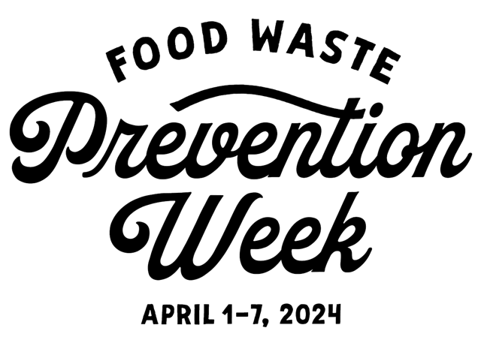
Feast of Words K-12 Student Poetry Contest Submission Rules
Theme: "What Food Means To Me" or “Love Letter to Food”

Choose Your Format:
- Haiku - 3 lines with a syllable count of 5-7-5
- Zip Ode - 5 lines Each number of your zip code determines the number of words in that line.
Eligibility: The contest is open to all Miami-Dade and Broward County K-12 students.
Deadline: The deadline for submission is Thursday, February 15, 2024. Submissions: Entries are submitted through the form https://forms.gle/MmoYgwYeDdqf7BMFA . Entries may either be typed in or uploaded as a word or PDF document. Teachers submitting several entries from a class should email: elaine@foodconservationalliance.com to arrange for class submissions prior to deadline.
Rules: Poems must be the work of an individual–not a group or collaboration. Poems must be the work of a human being in their entirety–poems written by an A.I. (or written by an A.I. and edited by a human) will be disqualified.
Judging Criteria: Entries will be judged based on creativity, originality, adherence to the theme, and overall poetic expression.
Prizes: Winners will be announced during Food Waste Prevention Week April 1-7, 2024. Prizes will be awarded for the top three entries in each category.
K-5, 6-8 and 9-12. 1st $300 2nd $200 3rd $100
Publication: Winning entries may be featured on the Food Waste Prevention Week website, social media platforms and other communications.
Note: By submitting an entry, participants and their legal guardians consent to the potential publication of their work and acknowledgment of the student's name and school in association with the contest

Rubric
Creativity (30 points) | Originality (10 points): Uniqueness of perspective within the haiku format.  Imagery (10 points): Effectiveness in creating vivid mental images.  Economy of Words (10 points): Conciseness in conveying a complete thought.
Adherence to Theme (30 points) | Relevance (15 points): Alignment with the theme "What Food Means To Me” / “Love Letter to Food”  Depth of Exploration (15 points): Extent to which personal connections and emotions related to the theme are explored.
Haiku / Zip Ode Form (20 points) | Structure (10 points): Adherence to the traditional 5-7-5 syllable pattern (Haiku) number of words per line in accordance with the zip code ( Zip Ode)  Language and Expression (10 points)
Clarity (5 points) | Clear and concise language
Evocativeness (5 points) | Ability to evoke emotions or provoke thought.
Impact (10 points) | Lasting effect and resonance on the reader.
100 Points Total

Haiku Tips
- Brainstorm Words and Images:
  - Jot down words or images related to your chosen theme. These can be nouns, verbs, or adjectives that capture the essence of the moment.
- Craft the First Line (5 syllables):
  - Create the first line with five syllables. This line should introduce the theme or set the scene.
- Build the Second Line (7 syllables):
  - The second line should have seven syllables and provide a bit more information or deepen the imagery.
- Complete the Third Line (5 syllables):
  - Finish with the third line, containing five syllables. This line often offers a resolution, surprise, or a contrasting element.
- Check Syllable Count:
  - Review each line to ensure it adheres to the 5-7-5 syllable structure.
- Refine and Revise:
  - Haikus thrive on simplicity. Aim for clarity and vivid imagery. Eliminate unnecessary words to create a concise and powerful poem.
- Consider Punctuation:
  - Haikus traditionally don't use punctuation. However, modern haikus may incorporate it for emphasis or to guide the reader.
- Read Aloud:
- Once you've crafted your haiku, read it aloud. This helps to identify any awkward phrasing or syllable count issues.

How to Write a Zip Ode
Write the numbers of your zip code down the left-hand side of the page. Each number determines the number of words in that line.
Note: If you have a zero in your zip code, that is a wild card! You can leave it blank, inert an emoji or symbol, or use any number of words between 1 and 9.

